**Practical No: 06 Stack of Raspberry Pi for better Computing and analysis**

The Raspberry Pi’s great, but it’s certainly not that powerful. One way to boost that power is to create a cluster computer.

Clustering together a bunch of Raspberry Pi’s isn’t exactly a cheap option, but it can still be useful if we just need a bit of a boost for some Raspberry Pi’s we already have sitting around. We need at least two Raspberry Pi’s for this, but we can use as many as we want. After getting the basics set up on each Pi, we can link them together with a couple of commands and end up with a more powerful cluster computer. It’s not exactly going to blow a modern computer out of the water with its performance, but it might provide the extra boost we need to finish off a project of your own.

We can use a Raspberry PI cluster to run almost any kind of distributed or parallel software. We can run our own LAMP cluster, Docker, Kubernetes, Hadoop, ElasticSearch, Cassandra and many others. Also learning languages like Javascript, Java, Pthon, R, and so on. We can use for Development, QA, DevOps, or Education.

A Raspberry Pi cluster running on Linux is not only cheap to make compared to what it can do but can also be used to make one's life easier when dealing with resource-intensive tasks such as compiling, continuous data parsing from the Internet or just learning how to manage a cluster using real hardware instead of resorting to virtual machines.

A cluster of Raspberry Pi’s is known as a “Bramble” (and sometimes a “Beowulf” cluster) and the biggest bramble ever built is believed to the made by GCHQ, who used 96 Raspberry Pi devices. This is used by GCHQ to teach big data crunching techniques.

**Hardware Requirements:**

4 x Raspberry Pi 3 B/ B+ computers

4 x MicroSD cards

5 x Ethernet cables

4 x USB cables

1 x A 5-port switch

1 x (optional) portable router

1 x A decent USB Power Hub

4 x (optional) Raspberry Pi coolers

4 x (optional) Raspberry Pi heat sinks

1 x A cluster rack

1 x Some (optional) brass spacers

1 x Duct tape

2mm and 3mm screws

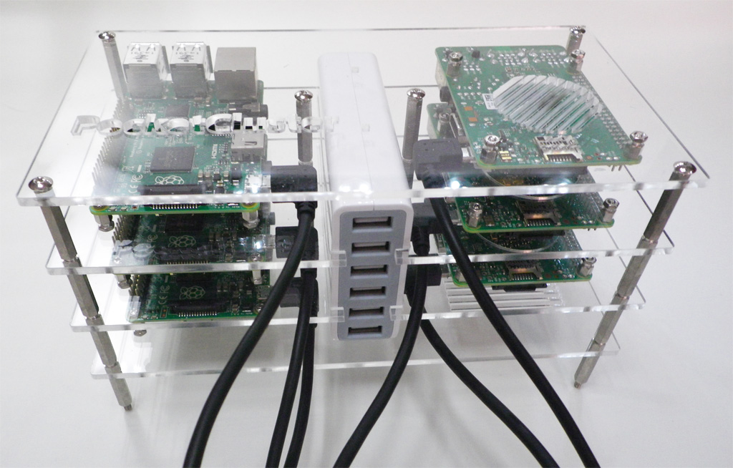

Raspberry Pi cluster

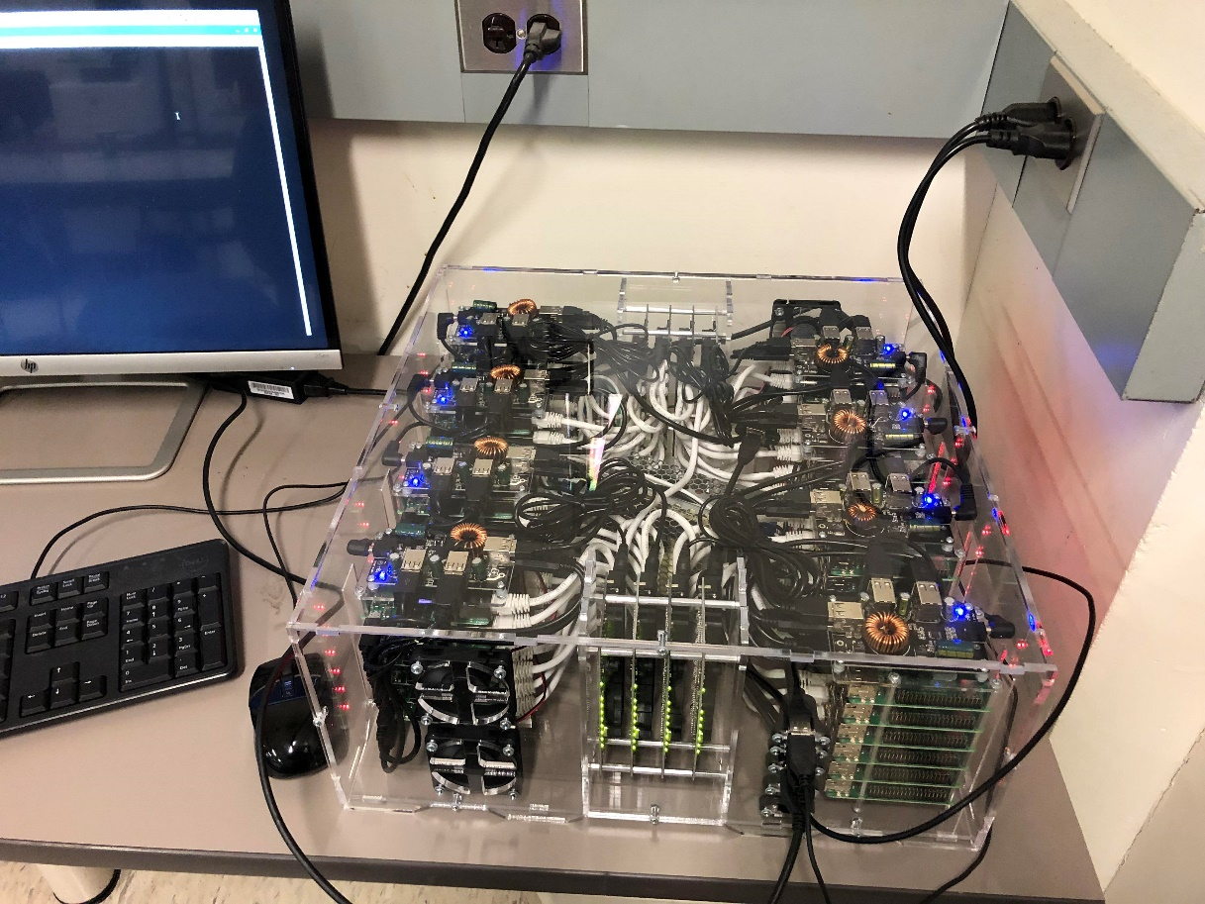

Raspberry Pi supercomputer cluster